**Date: 03-10-2023_**

**Batch: CSE-B9**

**Project Work: Review-2 Report**

**I. Project Title:**

Smarty Pants

**II. Datasets / Project Flow / Modules description:**

**Datasets -**

Alphabets, Words, Sentences, and Rhymes: Datasets containing lists of words, sentences, and rhymes categorized by difficulty levels. These can be used to teach language and literacy skills.

Images and Illustrations: Collections of images and illustrations of objects, animals, and scenes that can be used to create a visually engaging learning experience**.**

Game and Activity Data: Data related to interactive games and activities, including game mechanics, levels, and scoring.

Story Texts: Datasets containing the text of stories suitable for children aged 4 to 7. These stories can be categorized by themes, genres, and reading levels.

**Modules -**

**In-built Modules –**

**Speech Recognition:**

The SpeechRecognition module in Python, often referred to as "speech_recognition," is a powerful and user-friendly library for incorporating speech recognition capabilities into applications. It allows developers to convert spoken language into written text and offers compatibility with several speech recognition engines and APIs. This module simplifies the process of working with audio data and speech recognition services, making it accessible for a wide range of applications, including voice assistants, transcription services, and more.

Key features and components of the SpeechRecognition module include:

* Recognition Engines: The module supports multiple recognition engines, enabling developers to choose the one that best suits their needs. Some of the popular recognition engines include:
* CMU Sphinx (PocketSphinx): A lightweight, open-source, and offline speech recognition system suitable for simpler tasks.
  + Google Web Speech API: Integrates with Google's cloud-based speech recognition service, allowing online speech-to-text conversion.
  + Microsoft Bing Voice Recognition: Provides access to Microsoft's cloud-based speech recognition service, requiring an internet connection.
  + IBM Speech to Text: Integrates with IBM's Watson Speech to Text service for online speech recognition.
* Audio Recording: The module simplifies audio recording from various sources, such as microphones, audio files, or even streaming audio from the internet.
* Integration with Popular APIs: It offers easy integration with cloud-based speech recognition APIs like Google Web Speech API and Microsoft Bing Voice Recognition.
* Cross-Platform Compatibility: SpeechRecognition works seamlessly across different platforms, including Windows, macOS, and Linux.
* Support for Multiple Languages: Developers can recognize speech in various languages and dialects, depending on the recognition engine used.

**DateTime –**

The datetime module is a built-in module in Python that provides classes and functions for working with dates and times. It is part of Python's standard library, which means you don't need to install any additional packages to use it. The datetime module is incredibly versatile and allows you to perform a wide range of operations related to date and time manipulation.

Key components and classes within the datetime module include:

* datetime Class: The datetime class is the most commonly used class in the module. It represents a specific date and time, including information about the year, month, day,

hour, minute, second, and microsecond. You can create datetime objects to work with specific points in time.

* date Class: The date class is used to work with dates independently of time. It represents a date (year, month, and day) without specifying a particular time of day.
* time Class: The time class represents a specific time of day, including hours, minutes, seconds, and microseconds. It can be used to work with times independently of dates.
* timedelta Class: The timedelta class represents a duration or time difference. It's often used for performing arithmetic operations with dates and times. For example, you can add or subtract timedelta objects to/from datetime objects.
* tzinfo Class: This class is used for working with time zones. It allows you to create datetime objects aware of different time zones and perform conversions between them.
* strftime and strptime Methods: These methods are used for formatting and parsing date and time objects as strings. strftime is used to format dates and times into custom string representations, while strptime is used to parse strings into datetime objects.

**SQLite3 –**

The sqlite3 module in Python is a built-in module that allows you to interact with SQLite databases. SQLite is a lightweight, serverless, self-contained, and file-based relational database management system. Python's sqlite3 module provides a simple and convenient way to create, manipulate, and query SQLite databases directly from your Python code.

Here are some key aspects and features of the sqlite3 module in Python:

* Database Connection: To work with an SQLite database, you first create a connection object using the sqlite3.connect() function. You specify the name of the database file within the parentheses, and it will create a new database file if it doesn't exist.
* Cursor Object: After establishing a connection, you create a cursor object using the cursor() method of the connection. The cursor is used to execute SQL commands and fetch data from the database.
* Create Table: You can create database tables by executing SQL CREATE TABLE statements using the cursor's execute() method. This allows you to define the structure of your database.
* Inserting Data: Data can be added to the database using SQL INSERT INTO statements.
* Querying Data: You can retrieve data from the database using SQL SELECT statements. The cursor's execute() method is used for this purpose, followed by fetchone(), fetchall(), or fetchmany() methods to retrieve the query results.
* Committing Changes: After making changes to the database (e.g., inserting, updating, or deleting records), you should commit those changes using the commit() method of the connection.
* Error Handling: The sqlite3 module provides exception handling to catch and handle errors that may occur during database operations, enhancing the robustness of your code.

**User-defined Modules –**

**SmartyPantsOperations –**

This module contains core operations related to the application. The operations are:

* calculateAge(): This method is used to calculated the age of the user based on the date of birth entered by the user when signing up for the application**.**
* compareText(): This method is used to compare the original text and spoken text by user and return a dictionary containing key-value pairs as word as key and status as value. The status of word is classified as correct, wrong or missing.

**DataBase** –

This module contains operations used with database. The operations are:

* getUserDetails() – Returns the details of user based on email.
* checkEmailExists() – Returns boolean value, if the email exists in database.
* addUser() – This operation is used to add a new user.
* getUser() – Returns the details of user based on userId.
* updateScore() – Updates the score of a user based on the learningId.
* getScore() – Returns the score of a user based on userId.
* getContent() – Returns the content like image and text, the user is trying to learn.
* calculateScore() – Calculates and returns the overall score of the user.

**Project Flow –**

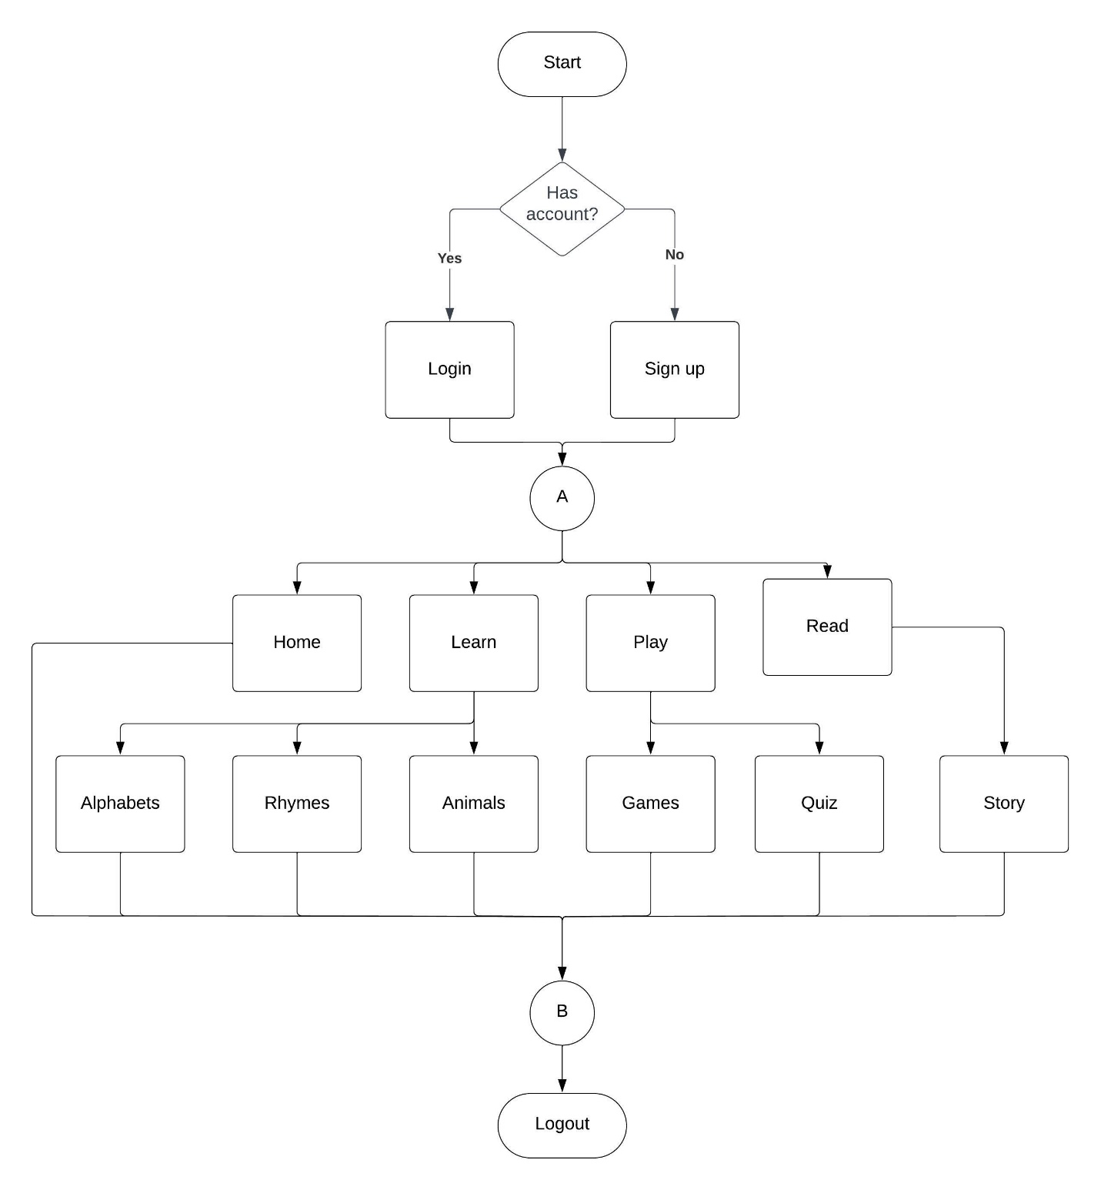

**III. Project Design (UML Diagrams) / Methodology / Framework / Architecture / Proposed Algorithm**

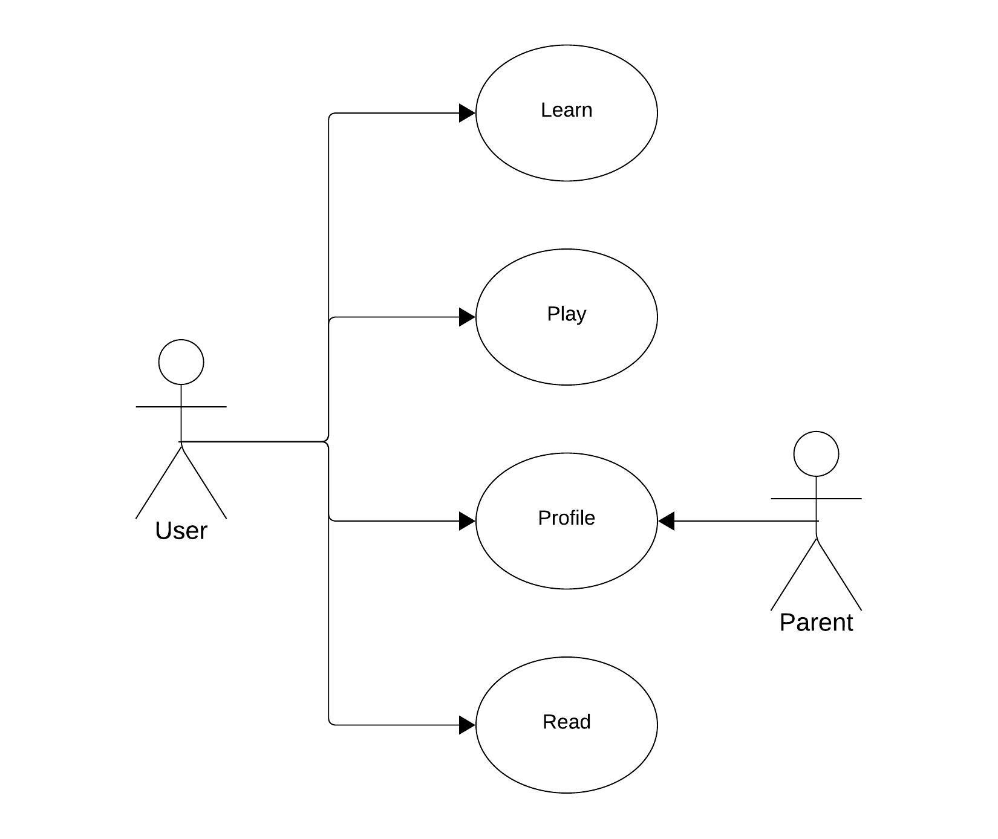

**Use Case Diagram –**

**Component Diagram -**

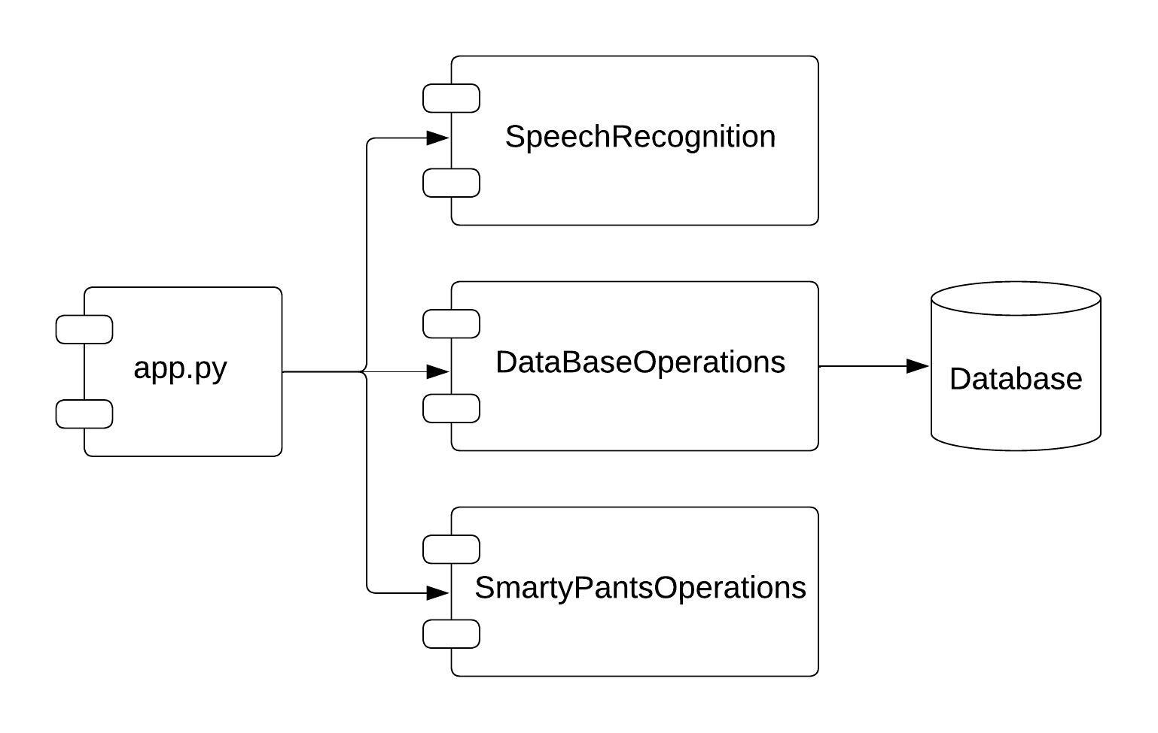

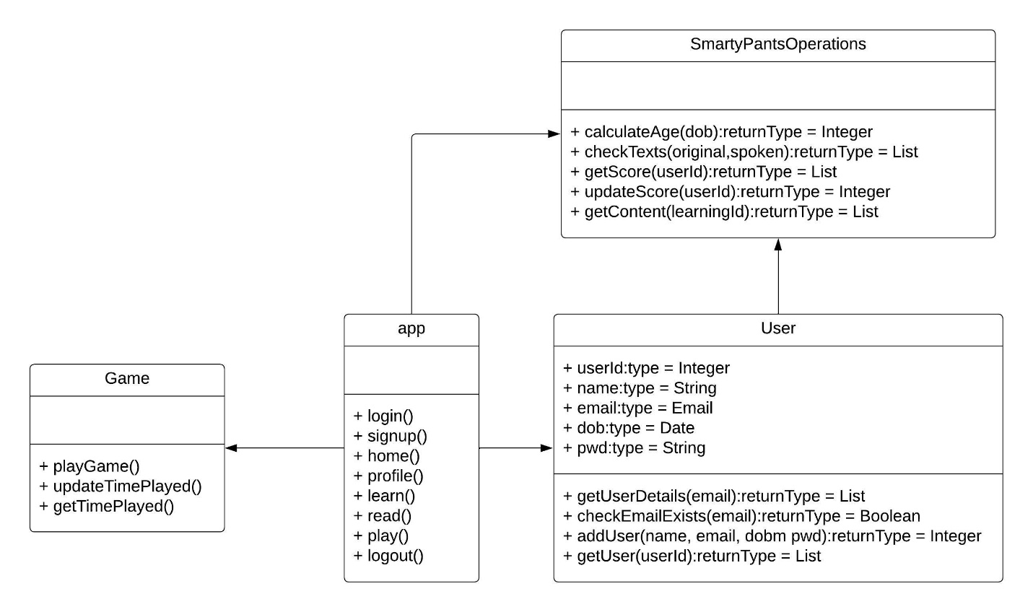

**Class Diagram –**

**Activity Diagram –**

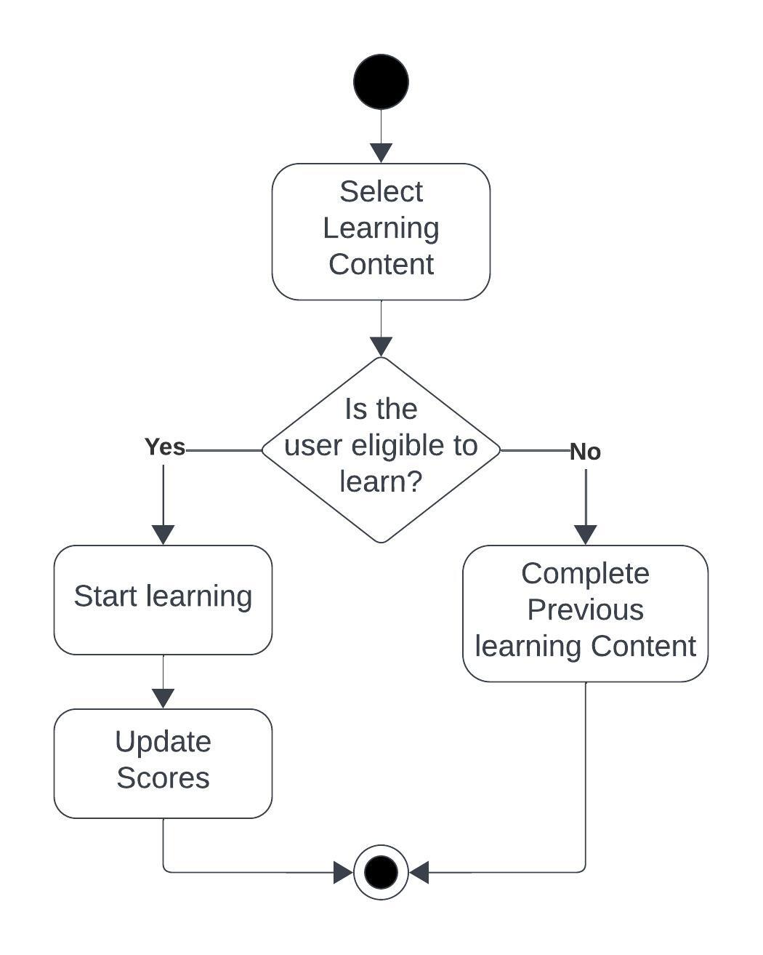

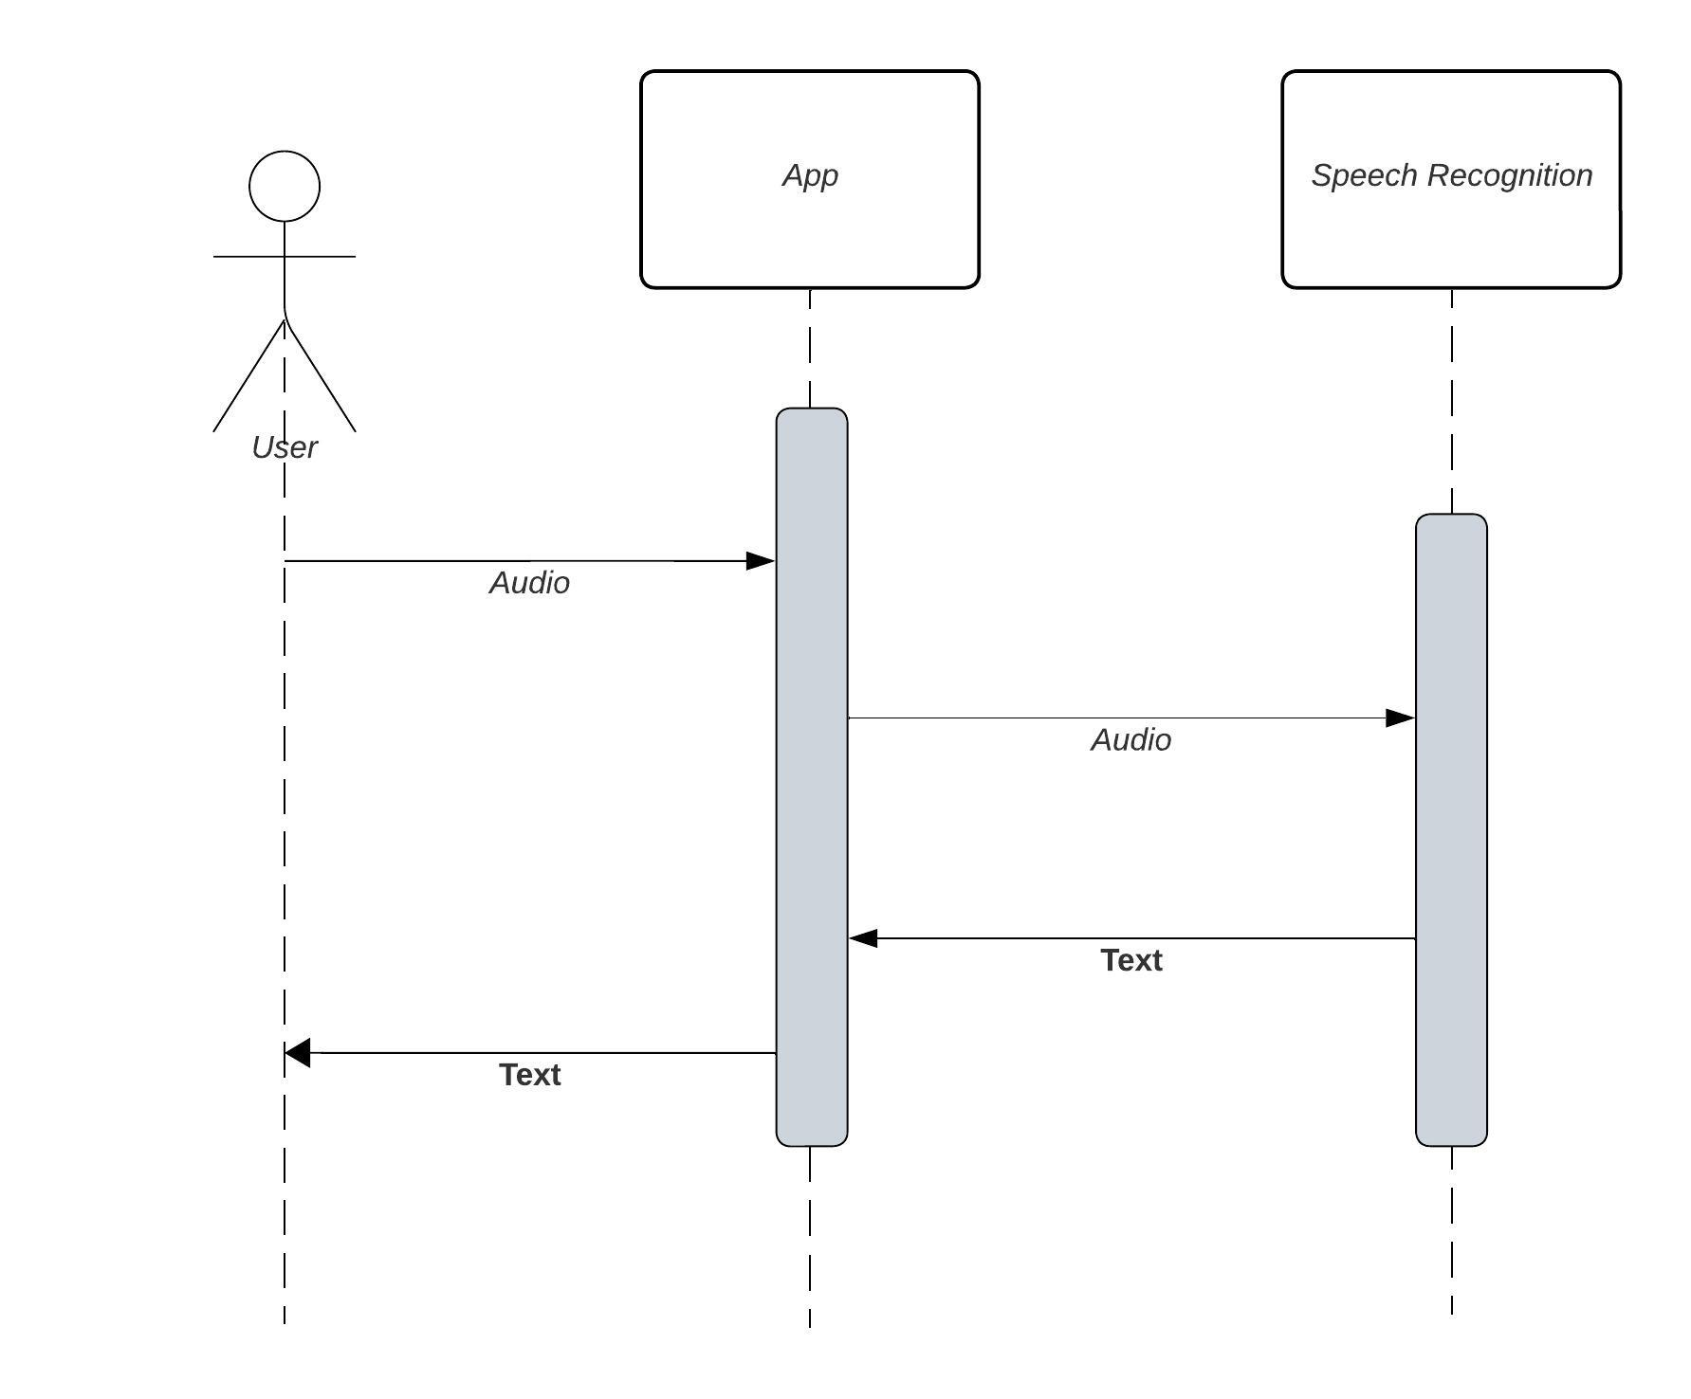**Communication Diagram –**

|  |  |  |  |  |
| --- | --- | --- | --- | --- |
| **Submitted by:** | | | | |
| **S.No** | **Roll No** | **Name of the Student** | **Signature of the student** | |
| 1. | 209X1A0593 | J Prem |  | |
| 2. | 209X1A05A9 | Pasala Sai Nivas |  | |
| 3. | 209X1A05A3 | Mitta Sai Mithil |  | |
| **Project Guide Name & Designation** | | | |
| Dr. N. Kasiviswanath  Head of the Department  Department of Computer Science and Engineering | | | |
| ___________________________ | | | |
| Signature with date | | | |